|  |  |
| --- | --- |
| New Jersey Department of Health  **Consumer, Environmental and Environmental Health Service**  **Food and Drug Safety Program**  **P.O. Box 369, Trenton, NJ 08625-0369** Telephone: 609-826-4935 Fax: 609-826-4990*www.nj.gov/health/foodanddrugsafety* **Application FOR Certificate of Free Sale (CFS)** | **FOR STATE USE ONLY** |
| Check/MO No. ______________  Amount  Tendered $________________  Processor ________________  Date Rec’d ________________ |

|  |  |  |  |  |  |  |
| --- | --- | --- | --- | --- | --- | --- |
| Name of Company  **Wayne County Foods, Inc** | | | | NJDOH License or Registration Number  **0012525** | | |
| Street Address  **360 Coit Street** | | | | Telephone Number  **(973) 399-0101** | | |
| City State Zip Code  **Irvington, NJ 07111** | | | | Email Address *(Required)*  **jrogenski@grovara.com** | | |
| Is product listed on Certificate of Free Sale under embargo, seizure or other restraint?  Yes  No  If yes, please explain. *(Attach additional sheet, if necessary.)* | | | | | | |
| If further verification/Apostille is required, please check below:  Mercer County Clerk’s Office or  State Treasurer’s Office (must indicate country of destination)  *Note: Refer to the Certificate of Free Sale Guidelines for the appropriate fees required.*  *For more information regarding this service and associated fees, please visit the Department of Treasury’s website at:*  [http://nj.go](http://nj.gov/treasury/revenue/njbgs/gsfaq.shtml#apos2)[v/treasury/revenue/njbgs/gsfaq.shtml#apos2](http://nj.gov/treasury/revenue/njbgs/gsfaq.shtml#apos2) | | | | | | |
| The following information must be included on the Certificate of Free Sale (CFS) form:  1.) Current date of inspection by the New Jersey Department of Health or the U.S. Food and Drug Administration (in the case of a Drug Company).  2.) Type of establishment: Food, Drug or Cosmetic establishment.  3.) Name under which establishment is licensed.  4.) Location of licensed establishment where products are manufactured and distributed.  5.) List of products to be certified.  6.) Signature and notarization will be completed by the New Jersey Department of Health. | | | | | | |
| Additional Requirements:  1.) The document must remain a single paged, typed document. HANDWRITTEN DOCUMENTS WILL NOT BE ACCEPTED.  2.) Please include product labels for all products listed on the Certificate(s).  3.) A certificate of analysis is required for all unfinished ingredients.  4.) Pre-paid return postage is required. | | | | | | |
| Number of Products Per Certificate | **Number of**  **Certificates Requested** | X | **Fee Per**  **Certificate** | | **=** | Total |
| CFS (3 or less items) |  | X | $50.00 | | = | **$** |
| CFS (4 through 9 items) | **1** | **X** | $75.00 | | = | **$75.00** |
| CFS (10 through 25 items) |  | **X** | $100.00 | | = | **$** |
| Product G.M.P. Certificate |  | **X** | $50.00 | | = | **$** |
| General G.M.P. Certificate |  | **X** | $50.00 | | = | **$** |
| Sanitary Letter |  | **X** | $50.00 | | = | **$** |
| Export Certificate |  | **X** | $50.00 | | = | **$** |
| Health Certificate |  | **X** | $50.00 | | = | **$** |
| **Total Number Enclosed:** | **1** | **Grand Total:** | | | | **$75.00** |

***Important: Enclose a separate check for the above Grand Total, made payable to the “NJDOH.” Any other checks such as to the NJ State Treasurer or the Mercer County Clerk must be separate checks.***

|  |  |  |
| --- | --- | --- |
| Name of Applicant  **Juliana Rogenski** | Title  **Dir of Operations** | |
| Signature | Date  **04/13/2019** | Telephone Number  **(215 ) 450-5953** |

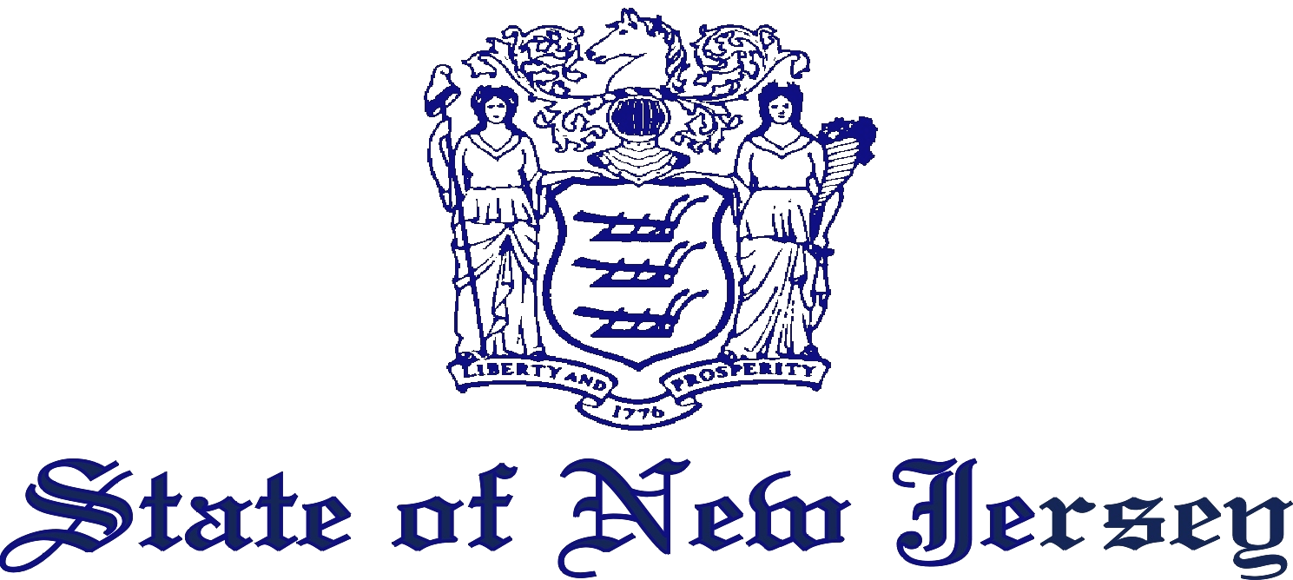

## DEPARTMENT OF HEALTH

CONSUMER, ENVIRONMENTAL AND OCCUPATIONAL HEALTH SERVICE

PO BOX 369

TRENTON, N.J. 08625-0369

**www.nj.gov/health**

**CERTIFICATE OF FREE SALE**

***Instructions: You are required to submit three (3) copies of this form, after completion.***

***Failure to forward the required number of copies will cause a delay in the processing of your Certificate.***

THIS IS TO CERTIFY that an inspection made on **10/18/18** by a representative of this Department of the sanitary conditions of the **food,** establishment of **Wayne County Foods, Inc** at **360 Coit Street, Irvington, NJ 07111** disclosed that said establishment was in a sanitary condition and was being operated in compliance with the provisions of the laws enforced by this Department.

THIS IS TO FURTHER CERTIFY that the following product(s):

|  |
| --- |
| Product Name Country of Origin  Purity Organic Lemonade – (16.9oz / 500ml) USA  Purity Organic Iced Tea & Lemonade – (16.9oz / 500ml) USA  Purity Organic Peach Paradise – (16.9oz / 500ml) USA  Purity Organic Strawberry Paradise - (16.9oz / 500ml) USA  Purity Organic Orange Mango Paradise - (16.9oz / 500ml) USA  Purity Organic Pomegranate & Blueberry Plus - (16.9oz / 500ml) USA |

distributed by **Grovara LLC at 3675 Market St. Ste 200, Philadelphia, PA 19104**, are labeled in compliance with the Food, Drug and Cosmetic Laws of New Jersey and are sold throughout New Jersey and the United States of America.

|  |  |
| --- | --- |
| **BELOW IS FOR STATE USE ONLY** | |
| Subscribed and sworn to before me this  ________ day of ________________________, 20____.  **Notary Public of the State of New Jersey**  MY COMMISSION EXPIRES: ____________________. | By_______________________________________________ |

**NOT VALID UNLESS THE RAISED SEAL OF THE NOTARY PUBLIC NAMED HEREON IS AFFIXED**