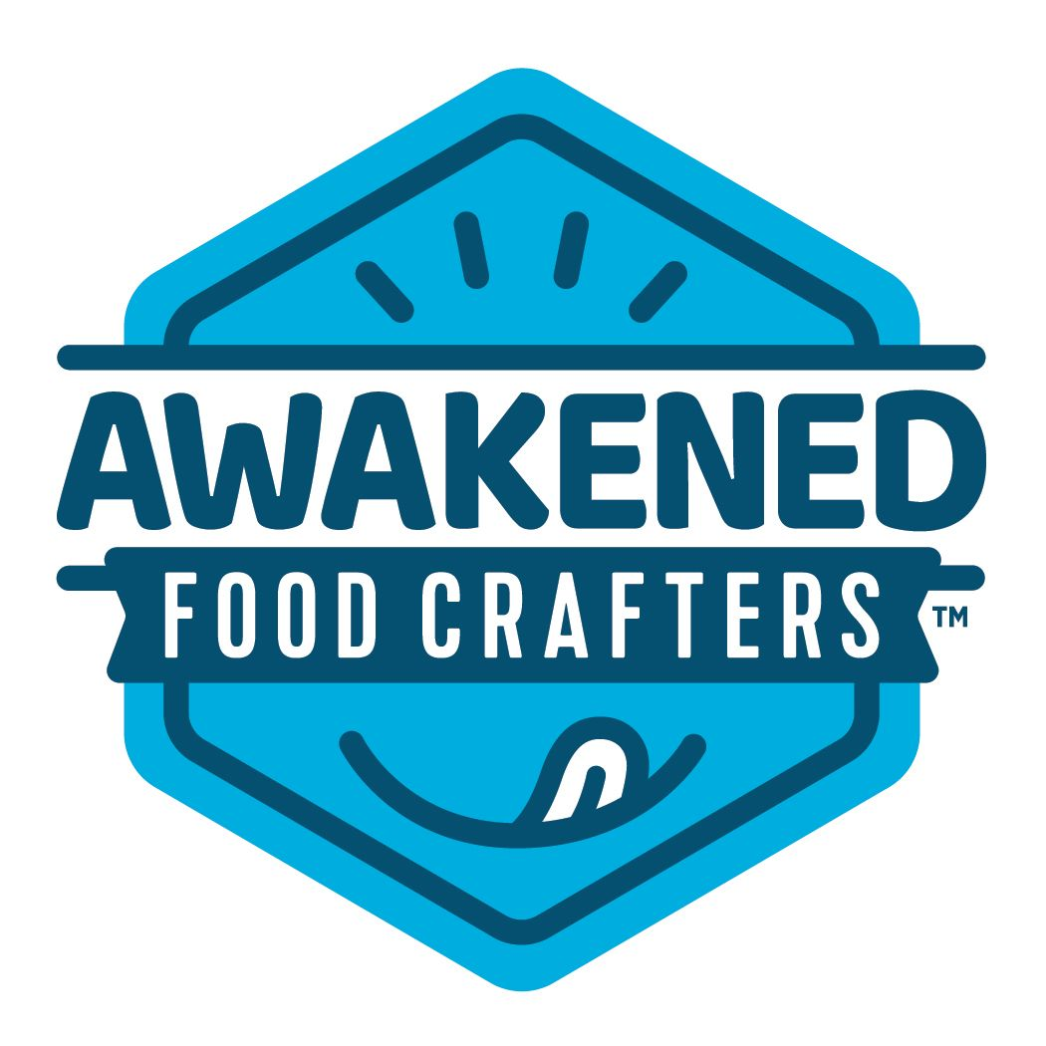

**Food Safety and Quality Commitment Statement**

Awakened Food Crafters, LLC prides itself on providing our customers with safe, quality food products. Awakened Food Crafters, LLC and its ownership, is committed to a culture of food safety by applying, adhering to, maintaining, and continuously improving the policies and procedures as they pertain to food safety. Awakened Food Crafters, LLC strives to provide clean, safe food through the use of Food Safety Modernization Act (FSMA) Preventive Controls and Environmental Monitoring requirements. Awakened Food Crafters, LLC also utilizes the most up to date FSMA Food Safety Plan risk assessments for all production processes that include prerequisite programs.

Awakened Food Crafters, LLC maintains high levels of food safety throughout our facility by continually training our employees in updated processing techniques and current food safety practices. Annual reviews of our food safety systems are required so that we can be confident our customers are receiving food products of the highest quality.

At Awakened Food Crafters, LLC we understand that providing our customers with high quality, safe food is the responsibility of all our employees. With this in mind, we commit ourselves daily to the manufacturing of products that we can be both proud of and assured to be of the highest quality.

Regards,

Dustin, Jeff, and Jared