- Object

Define management of system conform FSMA requirements within Mr Mallo.

- Definitions

FSMA= FDA food modernization act
7 chapters:
- Preventive controls for human food rule
- Preventive controls for animal food rule
- Produce safety rule
- Transportation rule
- Foreign supplier verification program rule (FSVP)
- Third party rule
- Intentional adulteration rule

PC Human= preventive controls for human food rule

FSVP= foreign supplier verification program rule

- Preventive controls for human food (title 21 of the code of federal regulation(CFR) part 117)

https://www.ecfr.gov/cgi-bin/text-idx?SID=57602477e2146c7d93f96ae73b0079eb&mc=true&node=pt21.2.117&rgn=div5

PCQI: preventive controls qualified individual

Management of Mr Mallo assigns Joris Van Rumst as PCQI for the Mellow Party and Confiserie Van Damme production sites.
- Training followed on 20/09/2018 (see ‘aanwezigheidsattest Alimento’)
- See ‘certificate of training’ Kristien Neyts

Subpart B-cGMP- current good manufacturing practices

Specific GMP activities which are important for food safety
- Determined during hazard analysis
- = preventive control
- Risk of cross contamination (microbiologic)= sanitation preventive control
- Risk of cross contamination (allergens)= allergen preventive control
- Defect action levels: means a level of a non –hazardous, naturally occurring, unavoidable defect at which FDA may regard a food product “adulterated” and subject to enforcement action under section of the FDA.

Subpart C- Hazard Analysis and Risk-Based Preventive Controls→Food Safety Plan

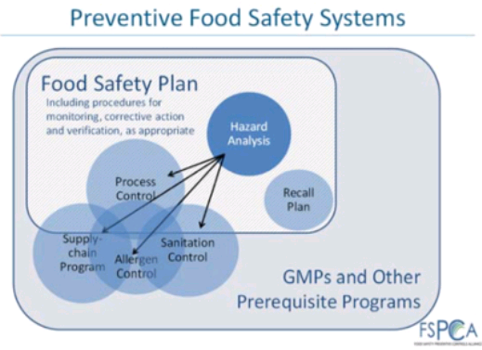

Definition food safety plan:
A set of written documents that:
- Is based on food safety principles
- Incorporates hazard analysis, preventive controls, supply chain programs and a recall plan
- Describes procedures to be followed for monitoring, corrective actions and
Verification

Food safety plan is managed by PCQI.
See members haccp team. Members haccp team are included in food safety team.

Content food safety plan: 7 elements
- Hazard analysis
- Preventive controls
- Supply chain program
- Recall plan
- Procedure for monitoring the implementation of the preventive controls
- Corrective action procedures
- Verification procedures

- Hazard analysis/identification/evaluation

See Haccp system

Biological dangers: pathogens, environmental pathogens
Chemical dangers: radiological dangers, residu pesticides, forbidden additives, allergens
Physical dangers: naturally present, unconsciously added, consciously added (food fraud)

All these dangers are taking into account in the existing haccp system and food fraud system.

Environmental pathogens are already taken into account in the existing haccp danger analysis.
Exception: radiological dangers. We have checked this potential danger, but this is not relevant for our type of product.
Our current haccp danger analysis is based on chance and effect.
Consumer target group is included in haccp study.

- Preventive controls

Definition:
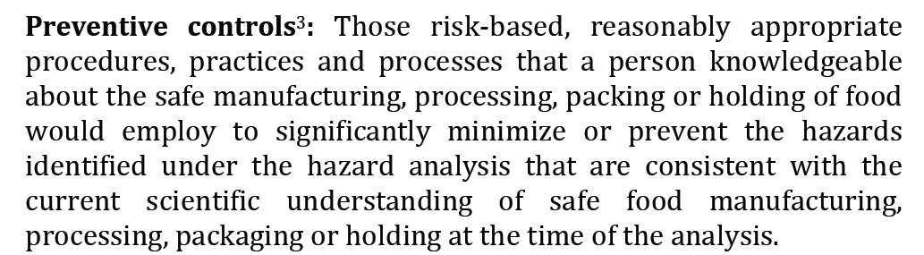

We can group the preventive controls in 4 categories:
- Process controls
- Food allergen controls
- Sanitation controls
- Supply chain controls

See haccp plan FSMA

  - Process preventive controls

Process preventive controls corresponds with the CCP we have determined in the haccp study (see definition CCP).
See haccp study: CCP metal detection (haccp plan & validation haccp plan)
Monitoring, critical limits, control measures: see haccp plan.
Also PVA’s which are related to process are seen as process preventive controls

  - Sanitation preventive controls

Definition: Procedures, practices, and processes to ensure that the facility is maintained in a sanitary condition adequate to significantly minimize or prevent hazards such as environmental pathogens, biological hazards due to employee handling, and food allergen hazards
This includes:
- Cleanliness of food-contact surfaces
- Prevention of allergen cross-contact and cross contamination from insanitary objects and from personnel to food, food packaging material, and other food contact surfaces and from raw product to processed product
Cross contact= cross contamination allergens
Cross contamination= cross contamination microbiological

See haccp plan FSMA. Our type of product is a low moisture product. Environmental pathogens taken into account: salmonella.
See flow: our production facility only has low risk, enclosed or non product zones
We have a sampling plan in our ‘low risk’ production zone (analysis of extracted dextrose; see haccp plan FSMA)

See analysis sampling plan:
    - Finished products (test, frequency ,limits)
    - Surfaces (test, frequency, limits)
Product Testing Sampling Plans - Microbiological t
  - Allergen preventive controls

Definition : procedures, practices, and processes to control food allergens.
Include those procedures, practices, and processes employed for:
    - Ensuring protection of food from allergen cross-contact, including during storage, handling, and use
    - Labelling the finished food, including ensuring that the finished food is not misbranded
The eight foods identified by the law are
1.Milk
2.Eggs
3.Fish (e.g., bass, flounder, cod)
4.Crustacean shellfish (e.g., crab, lobster, shrimp)
5.Tree nuts (e.g., almonds, walnuts, pecans)→coconut
6.Peanuts
7.Wheat
8.Soybeans

-Avoiding cross contact with allergen.

See allergen policy in haccp system.
After an allergen containing production a validated cleaning has to be executed.
Verification of cleaning line 3 is executed by means of a checklist and analysis.
Allergen containing production are planned together (production planning).

For all raw materials, a up to date master list of allergen ingredients is present, see matrix.

-labelling

See existing procedure regarding labelling.
- Check of incoming labels
- Check of new labels (approval procedure)
- Check of labels during production
  - Visual check by QC and packaging supervisors
  - planning is referring to label to be used
  - barcode scanning by QC and packaging supervisors
  - line clearance procedure
  - rules regarding old packaging

Supply chain preventive controls related to allergens: necessary information from suppliers (used allergens & allergen policy)

FALCPA: Food Allergen Labeling and Consumer Protection ACT
- legal declaration of 8 ‘major food allergens’
- 2 possibilities:
  - In ingredient list
  - After ingredient list: ‘contains….’
Or a combination of both

  - Supply chain preventive controls

- Dangers with minimal food safety impact: supply chain management as GMP
- Dangers with specific food safety impact: necessary to have a preventive control (unless the danger is managed by a preventive control in the process)
- A preventive control for a hazard in a raw material or other ingredient when the hazard in the raw material or other ingredient is controlled before its receipt
Examples : salmonella in coconut, salmonella in chocolate

Supply chain preventive controls: see purchase and supplier approval procedure + supplier evaluation procedure
See existing sampling plan (analysis year plan) with included microbiological testing of raw materials.
Supplier evaluation is executed yearly.

  - Preventive control management

See Haccpplan conform FSMA: management of PC is included (monitoring, direct/preventive actions, verification, records)
See procedure improvement actions & procedure non conform products

Validation: see haccp validation for metal detection.
Seen the microbiological stability of our product, validation for the other PC is not necessary.

Sampling plan and analysis year plan is part of the verification.

Yearly review of food safety plan (together with Haccp review)

Checklist to be used for review:

Wat | Wie | Wanneer
Food safety team | Food safety team | 1x/jaar
Product flow | Food safety team | 1x/jaar
Hazard analysis | Food safety team | 1x/jaar
Process preventive controls | Food safety team | 1x/jaar
Food allergen preventive controls | Food safety team | 1x/jaar
Sanitation preventive controls | Food safety team | 1x/jaar
Supply chain program | Food safety team | 1x/jaar
Recall plan | Food safety team | 1x/jaar
Updated plan signed by CEO | Food safety team | 1x/jaar

  - Record keeping

See procedure record keeping

- Recall plan

See instruction crisis management/recall

Contact info for FDA:
https://www.fda.gov/Safety/Recalls/IndustryGuidance/ucm129334.htm

Effectivity is monitored during recall (to be provided to FDA)

- Intentional adulteration rule

See existing procedures regarding food defense

